
Exploring HOW BUSINESS Intelligence tools and Geographical information systems can address delayed response and resource allocation in disaster management
Author: Jedd Madayag

Contents
Declaration 1
Abstract 1
Introduction 2
Literature Review 3
“ESPLA-M” & OLAP models 4
Field 1: Emergency Situations 4
Field 2: Flood Situations 4
Geographical Information Systems (GIS) 5
Methodology 8
Conceptual BI Model (Case Study in Phuket, Thailand) 8
BI analytics and data visualisation 12
GIS for Flood Disaster Management (Case Study for Allahabad Sadar, India) 14
Results 18
Discussion 19
Conclusion 20
Future Work 20
Bibliography 21

Declaration
I hereby confirm that the work presented here in this report and in all other associated material is wholly my own work.
This work is licensed under a Creative Commons Attribution-Non-Commercial No Derivatives 4.0 International License.

Abstract
This study focused on exploring how Business Intelligence (BI) and Geographical Information Systems (GIS) can address delayed response and resource allocation in disaster management. The methodology for this study focuses on a qualitative approach by providing an in-depth analysis on a BI case study from Phuket, located in Thailand, and the GIS case study in Allahabad Sadar, located in India. The research focuses on how BI tools like OLAP models (Online Analytical Processing), the multidimensional star schema model and visualisations can transform data gathered from disasters and how it can be turned into valuable insights to enhance decision making before disasters arise, which enables for proactive disaster response. Similarly, the ‘ArcView’ GIS provides essential spatial analysis for locating disaster-prone areas that have relief camp routes for efficient resource allocation. Limitations have also been acknowledged, specifically noting that research on Business Intelligence is relatively obscure in disaster response and resource allocation, in comparison to more traditional technologies like real-time sensor networks relating to the Internet of Things. Regarding future work, research could have included a wide range of case studies evaluating how different technologies like IoT sensor devices can better address delayed response and resource allocation.

Introduction
In disaster management, response time and efficient resource allocation play critical roles in preventing both man-made and natural disasters. Delayed decision making, and the misallocation of resources tend to be challenges in disaster management, leading to severe consequences, as seen in previous disasters.
For example, due to a delayed response to Hurricane Katrina, thousands were left without proper shelter, food, water and medical supplies for days as they waited to be rescued (Chua, Kaynak and Foo, 2007). This highlights the importance of response times in disaster management as, without a timely response, casualties will arise. For instance, from 1995 to 2022, 11,360 natural disasters occurred with a mean of 398 per year. The occurrence of these disasters caused many casualties, for example, Asia suffered the most disaster (4390) and had the highest number of casualties (918,198) (Tin et al., 2024). These figures demonstrate the need for improved disaster response, particularly in enhancing response time and providing efficient resource allocation to minimise casualties.
Furthermore, the lack of resource allocation has been an issue in disaster management. This problem has been observed in large-scale natural disasters, showing a lack of coordination among different relief organisations in resource distribution in a specific area (Mondal et al., 2019). This inefficient resource allocation is likely due to poor communication and decision making. Addressing these challenges will require technological systems and solutions to improve coordination and decision making in disaster response.
Notably, Geographical Information Systems (GIS) that incorporate scientific models are commonly employed for running hazard simulations in support of planning mitigating efforts (Jefferson and Johannes, 2016). This means GIS systems can be integrated to improve disaster management as they are able to analyse data based on location, which can give a thorough description of the searched area and will give insight as to whether it’s disaster-prone. On the other hand, Celina Olszak believes that Business Intelligence systems are some holistic infrastructures of decision-making (Olszak and Ziemba, 2006). Not only that, but it has been shown that BI concepts may contribute towards improving quality of decision making in any organisation (Olszak and Ziemba, 2006). This means that these systems can be used to improve disaster preparedness by enhancing the decision-making process in disaster-prone countries. Therefore, Business Intelligence (BI) offers a wide range of tools to improve data-driven decision making.
This paper will aim to explore how BI and GIS systems can be used to address the challenges in disaster management: delayed response and resource allocation. The study aims to highlight how GIS systems and BI tools can provide more streamlined communication and support proactive decision making in disaster prone regions. Moreover, establishing the technological aspects of GIS systems and BI tools and models, and how they have been used in disaster management, will provide a deeper understanding of how these technologies can help tackle these problems. Additionally, case studies on how these technologies have been implemented to demonstrate the effectiveness of these technologies will be explored. Lastly, discussing the findings from the case studies and their effectiveness in resource allocation and disaster response will be evaluated. With this, recommendations on how these technologies can be improved will be suggested to further support decision making for improved disaster response and resource allocation.
Overall, integrating GIS systems and BI can be a possible solution for these challenges. These systems and tools can provide better decision-making, data-driven understanding and better predictive analysis, all of which will be beneficial to countering these challenges. As a result, disaster management agencies will be able to enhance their disaster response strategies and their resource allocation which can essentially reduce the impact of these catastrophic events in disaster-prone countries.

Literature Review
Business Intelligence (BI) has become a cornerstone of data-driven decision-making in modern enterprises. With the increasing complexity of data, traditional methods often fall short in providing actionable insights (Franciskus Antonius Alijoyo et al., 2024). It is no surprise that technology and data will become more complex in the future, which can potentially lengthen daily tasks. With traditional methods often being outdated in providing valuable insights, it is important to adapt to these uncontrollable situations. As data is growing exponentially, storage, processes, analytic tools and technologies become more important for BI solutions (KARACAN, H. and Şirin, E., 2017). Therefore, Business Intelligence can be utilised to make data-driven decisions which can be useful in resource allocation and disaster response. DataCalculus, a software company, believes that Business Intelligence (BI) plays a crucial role in disaster management. Through the leveraging of data analytics, emergency response and recovery efforts can be improved . They also state that Business Intelligence (BI) can transform disaster management by providing real-time data analytics, which enables rapid response during emergencies. With proper and descriptive data analytics, disaster-prone countries can respond more effectively and prepare earlier which improves the disaster response. Predictive analytics capabilities allow for proactive disaster preparedness . In June 2022, a predictive analytics solution was presented, which consisted of different categories of weather data. The aim of this predictive analytics solution was to track the accurate water levels which was useful as low water levels can lead to a concerning low supply of water which is harmful to the environment. In the end, their solution on evaluating real-life open data from the Canadian city of Winnipeg demonstrated the practicality of their solution in predicting water levels (Bouttell et al., 2022). Therefore, integrating predictive analytics is extremely important since it allows disaster-prone countries to forecast potential disasters, allowing these disaster-prone countries to improve their recovery efforts.

“ESPLA-M” & OLAP models
To address the common problem of delayed response in disaster management, OLAP (Online Analytical Processing) models can be used to analyse data from different perspectives. It can be used as a supplement to cluster analysis for fast and effective data mining (Alkharouf, Jamison and Matthews, 2005). In 2012, an emergency monitoring system “ESPLA-M” was developed for online analytical decision making. The system was designed to solve the problems associated with data integration, analytical processing and visualisation of analytical results (Ieee.org, 2024). Overall, integrating BI-integrated tools into emergency monitoring can be an innovative way for countries to predict upcoming disasters which, as a result, can improve their decision making, leading to better disaster response times. Moreover, these OLAP models were applied to a Siberian territory that has high levels of natural and anthropogenic emergency hazards (Ieee.org, 2024). The OLAP (Online Analytical Processing) tools enabled the user to perform the monitoring of natural and human made emergency situations from different perspectives. The development of these systems was an approach to provide efficient improvement of monitoring disasters (Ieee.org, 2024). As a result, a couple of OLAP models were developed to estimate the emergency risk.

Field 1: Emergency Situations
OLAP-model: Controlled Emergencies
Dimensions: Year, Emergency data, Emergency liquidation data, Place, Emergency type, Emergency scale and Emergency cause.
Facts: Deaths, victims, emergency count and material damage.
The emergency monitoring system includes the number of sensors of automatic control of hydrological, seismic and flood situations (Ieee.org, 2024). This OLAP model focuses on monitoring past emergencies to pinpoint trends and patterns in the area, such as how frequently the disasters occur and the impact of these events in the area, which can be identified through the facts which consists of deaths and damage to infrastructure. Exploring the dimensions of the OLAP model can give access to a range of perspectives which can support in-depth analysis from many areas.

Field 2: Flood Situations
OLAP-model: Flood forecast
Dimensions: Year, Territory, Hydro posts, River, Data of expected flood, Data of fact flood in the last year
Facts: Minimal expected water level, Maximal expected water level, Fact water level in the last year.
This OLAP model focuses on forecasting flood levels in a certain area. For instance, in the dimensions, data within the date of expected flood and the maximal expected water level can be analysed to manage water levels before they escalate. As a result, the correct preparations can be carried out which can prevent infrastructure from being damaged and can, therefore, mitigate the loss of lives in the area.
OLAP-model: Hydraulic facilities condition
Dimensions: Year, Place, Water body, Hydraulic facilities, Hydraulic facilities type, Hydraulic facilities state
Facts: Volume of hydraulic facility, Square of hydraulic facility
This OLAP model focuses on the statistics and conditions of nearby facilities that help to reduce floods, hence why both the type and state of the hydraulic facilities are included in the OLAP-models. It is extremely important that the facilities are monitored and maintained to prevent them from being destroyed and, consequently, cause a huge rise in water levels.
From these models, they were able to conclude that these technologies can improve emergency monitoring. They also concluded that OLAP technology allows a user to perform monitoring of natural and anthropogenic emergency situations (Ieee.org, 2024). Overall, these OLAP models can heavily enhance the monitoring of disaster management in disaster-prone areas. Therefore, OLAP systems can allow for the analysis of data from multiple perspectives which can give a more structured and cautious approach in disaster preparedness.

Geographical Information Systems (GIS)
To address the issue of delayed response in disasters, the integration of ‘Geographical Information Systems’ (GIS) can be a possible solution. With the development of remote sensing and GIS technologies, these are applied to periods of flood disaster monitoring and evaluation (Hu et al., 2007). GIS systems are responsible for gathering, storing, managing, analysing and visualising data (Andrei Kirilenko, 2022). GIS systems have been developed to perform the analysis of data collected from disasters for early warning or mitigation measures, at the national and international scale (Giardino et al., 2012). In the last decades, natural hazard analysis has been made worldwide by developing satellite-bearing methods. Because remote sensing is a key implementation in GIS systems, they provide various information based on special capabilities of instruments or sensors on satellites: in the case of earthquakes, the satellite observations have the major advantage of covering almost all the areas of seismic activity through the world in a short duration (Giardino et al., 2012). Therefore, integrating GIS allows for better geographical data analysis allowing countries to register early disaster assessment for awareness situations (Giardino et al., 2012). Overall, the data gathered from the satellites can enable for more accurate analysis on disaster prone areas, allowing for better emergency monitoring. Furthermore, to address the issue of resource allocation, the American Red Cross used GIS technology for a variety of tasks to better target its resources before, during and after a disaster (Richardson and Renner, 2007). To identify areas based on likely level of damage, Geographical Information Systems were used to determine the number of house units in the area (Richardson and Renner, 2007). Integrating GIS systems can give valuable information about areas that may have suffered massive damage, from which this data can be used to allocate the relevant resources to those affected areas. Also, GIS was then used to better understand the scope of the disaster and how assisted units might be affected through the data obtained from FEMA’s (Federal Emergency Management Agency) multiagency coordination system (Richardson and Renner, 2007). The FEMA MAC data used satellite imagery and “boots-on-the-ground” information to make assessments of areas impacted by the hurricanes (Richardson and Renner, 2007).
To address the issue of poor resource allocation in disaster management, a decision support system based on GIS and queuing theory was developed to determine resource allocation of an operational area (Rasekh and Vafaeinezhad, 2012). It is a well-known fact that allocation of resources for earthquake response operations is an essential aspect of disaster management (Rasekh and Vafaeinezhad, 2012). Their system was developed to provide efficient resource allocation in Tehran, the capital of Iran, with its centre geographical coordination of 35° 39' 10'' and 51° 21' 33'' latitudinal and longitudinal (Rasekh and Vafaeinezhad, 2012). The area of interest has a population of 32,239 people, whom are the occupants of 4843 building parcels (Rasekh and Vafaeinezhad, 2012). The selected site is located on the ray fault which makes the area one of the most earthquake-prone districts. Notably, a framework that allows the examination of GIS utilisation in disaster management can help to reduce the duration of the response phase and improve the efficiency of resource assignment to different urban districts with the employment of GIS (Rasekh and Vafaeinezhad, 2012). Upon applying a GIS to the case study area, Figure 1 was produced which shows the damaged points in grey and the unaffected areas in green.

Figure 1.
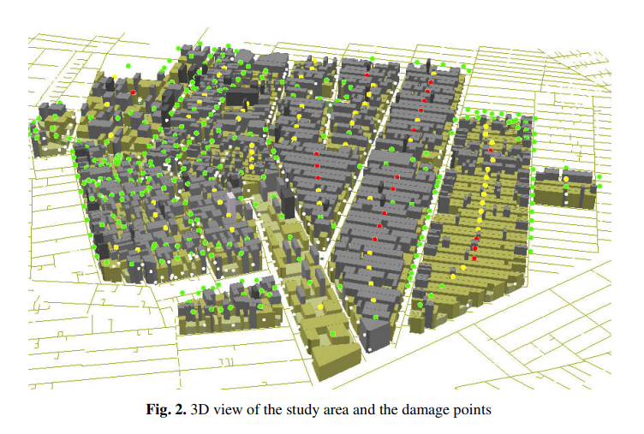 Source: Adapted from Rasekh and Vafaeinezhad, 2012 [19]
As seen in Figure 1, the 3D GIS mapping view of Tehran’s municipality district 17 shows the affected areas after an earthquake. With this visualisation, analysis of spatial data of the urban area can be performed. This allows for better emergency planning and resource allocation to damaged areas as responders can modify the type and proportion of resources allocated depending on the affected areas. The damaged points on the GIS were the focus of the SAR teams. Overall, the visualisations provided by Geographical Information Systems show the distribution of damage, as well as the demands of the areas that have been affected by a disaster, which can support strategic planning and help with specific resource allocation strategies.
Figure 2.
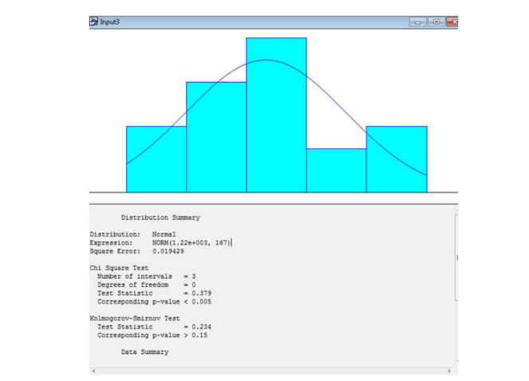
Source: Adapted from Rasekh and Vafaeinezhad, 2012 [19]
As seen in Figure 2, a central element to their approach was their Search and Rescue (SAR) queuing system, which puts affected victims in a queue. Every SAR team was assigned with three important tasks: securing, searching and rescuing (Rasekh and Vafaeinezhad, 2012). The queuing model was defined by service rate and arrival rate. For casualties without a secondary disaster such as aftershocks or resulting fires, the arrival rate was 20 (Rasekh and Vafaeinezhad, 2012). The service time was calculated by applying a statistical test called ‘Kolmogorov-smirnov test. Through this test, they gathered that the nearest statistical distribution for the service time is NORM (1.22e + 003, 167) which is a Normal distribution with the mean of 20.28 hours and a standard deviation of 2.78 hours (See Figure 2) (Rasekh and Vafaeinezhad, 2012). This result shows the average time it takes for the search and rescue teams to arrive in the damaged area and complete their assignments. Therefore, the analysis is crucial for the SAR queuing system as the values from this theory were implemented into the GIS system to support resource allocation strategies. This allowed SAR teams to function and increase survival rates of affected victims. Overall, pairing different theories and technologies, like the queuing theory with GIS, can enable disaster agencies to optimise the timing of their response through analysis of past data. In turn, this increases the survival rates of affected regions as they can receive resources sooner.

Methodology
A qualitative methodology will be necessary for this research. It will focus on the analysis of case studies, as opposed to the collection of numerical data, to explore how Business Intelligence and Geographical Information Systems have been implemented in disaster management. Examining these case studies will provide an understanding of how the application of these technologies can improve disaster response and resource allocation. The case studies will entail how BI and GIS systems have been applied to disaster-prone areas, including the conceptual BI model in Phuket, Thailand and the use of the Geographical Information System ‘ArcView’ which was applied to Allahabad Sadar, located in India. Each case study will be subject to in-depth analysis on the implementation of these technologies. It is important to focus on the technological aspects of the case studies such as Geographical Information Systems, Business Intelligence tools, star schemas, ETL processes, OLAP (Online Analytical Processing) and data visualisations. The methodology aims to provide thorough explanations on the case studies, from which valuable insights can be gained, and then viable solutions can be given for the improvement of ‘Geographical Information Systems’(GIS) and ‘Business Intelligence’ (BI), to provide better disaster response and more efficient resource allocation.

Conceptual BI Model (Case Study in Phuket, Thailand)
Figure 3.
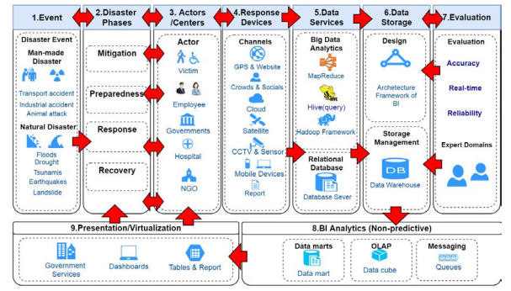 Source: Adapted from Panrungsri and Sangiamkul., (2017) [18]
As seen in Figure 3, the conceptual model of BI aims to enhance disaster management by focusing on the processing and evaluation of data. There are 9 phases in the model, with each phase playing an important role. The first phase focuses on categorising the type of disaster, whether it is natural or man-made. It is extremely important to research and determine the type of disaster so that the country can make the correct preparations, such as implementation of physical protection like flood barriers or shock absorbers. Once the disaster type has been identified, disaster management is then conducted in the second phase. The first stage of this is mitigation, which attempts to minimise or fully prevent loss of life and damage to the environment. The second stage is preparedness, where plans and strategies must be followed to ensure post-disaster operations can be carried out smoothly. The third stage is about effective response which revolves around a country’s active response (through physical actions such as rescue efforts) to disasters with the aim of saving lives, reducing economic losses and alleviating suffering. Finally, the last stage of disaster management focuses on recovery, which begins immediately after any threat to human life has been subsided . As a result, countries will be able to take the necessary recovery measures to restore the affected area, such as the removal of debris in the context of infrastructural damage. The third phase of the model concerns the gathering of useful data from trustful sources. These sources include government websites, hospitals and even potential victims that have experienced these catastrophes first-hand. All this data can be beneficial for analysis in the later stage of the BI model. The fourth phase focuses on the responsive devices such as the cloud system, mobile devices, CCTV, sensors and even social media platforms. These devices can also be used actively during the disaster, meaning real-time data can be collected. After the disaster has occurred, it is important to relay the information to the public, such that awareness is spread. The fifth phase is the data collection from data services. It focuses on Big Data which revolves around the notion of the 4V’s: velocity, volume, variety and veracity. Before Big Data is used, data must be processed to remove any inconsistencies or incompletions. The BI model has suggested three programs to use. The first program is MapReduce which is a big data analysis model and preprocesses data using a parallel algorithm on computer clusters, typically Apache Hadoop clusters or cloud systems like Amazon Elastic MapReduce clusters. MapReduce can be used in disaster management by processing large datasets from different countries. Secondly, Hive enables data summarisation, querying and analysis. Hive queries are written in HiveQL. It allows for the organisation of structured and unstructured data. It is extremely important in disaster management as any unnecessary data could affect the data analysis and visualisation which will hinder the decision-making process, as responders would be interpreting an inaccurate model. Next, Hadoop Framework can be used to manage the data and process large quantities of it. In summary, once the data has been processed, it is important to store it for potential use in the future. Finally, once the data has stored and cleaned, it can be used for frameworks which can help to provide a more structured approach to data analysis.
The sixth phase is data storage. This is where pre-processed data is stored into a data warehouse, which is defined by a multidimensional conceptual model. Data warehouse is mostly implemented on standard or extended relational DBMSs, ROLAP and MOLAP servers (Panrungsri and Sangiamkul, 2017). Data warehouses provide storage, functionality, and responsiveness. They contain historical, summarised and consolidated data over extended periods of time which can support decision-making process (Candidate, n.d.). This is because responders can base their decisions and plans of action off past patterns and observations. Data warehouses can have a big impact in natural disaster management as it improves the efficiency of rescue operation, as it has the promise of enabling organisations to generate cost-effective reports and analysis enhances decision making (Candidate, n.d.). Next, the seventh phase is about data warehouse evaluation which is necessary for analysis (Panrungsri and Sangiamkul, 2017). Data warehouses are essential for organising the stored data. Through data warehouse evaluation, the consistency and reliability of the data can be checked to provide for better analysis in the last stage, which focuses on using the data and transforming into visualisations like graphs, charts and plots. The eighth phase, BI analytics, solely focuses on analysing the data gathered for better insights. OLAP (Online Analytical Processing) can be used to analyse data from different perspectives. By looking at the data from different perspectives, analysis can be conducted to support the decision-making process. Finally, the ninth phase, is where the data is put into visualisations like graphs, charts and dashboards. These presentations/visualisations are incredibly simple to read and allows disaster prone countries to forecast upcoming disasters, enhancing disaster preparedness. However, from my perspective, the main limitation of this BI conceptual model is the excessive number of phases. The need to go through multiple phases increases the duration of the decision-making process and, therefore, the full assessment of the disaster will be slower. A more simplified model should be implemented to ensure the time taken to respond and allocate resources is minimised.
Figure 4.
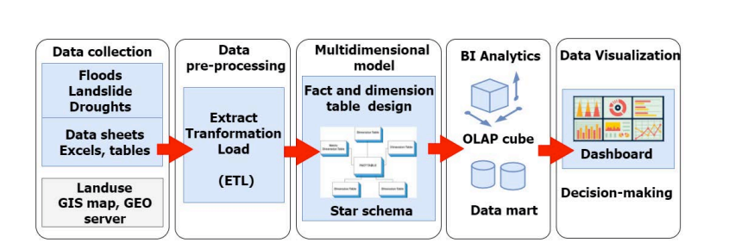 Source: Adapted from Panrungsri and Sangiamkul., (2017) [18]
As seen in Figure 4, the Business Intelligence Model was then applied to the study area, Phuket province in Thailand on the BI model being applied to the area. The BI model involves several phases like data collection, data pre-processing, multidimensional modelling, BI analytics and data visualisation. All these phases were significantly important for disaster management in the study area. The first stage focuses on gathering spatial data and structured data from multiple sources. The Excel sheets and tables include structured data regarding floods, landslides and droughts. Moreover, spatial data is collected through GIS (Geographical Information System) which can give insight into the shape of the landscape. Both structured data and spatial data must be utilised correctly for analysts to manage disasters and improve their decision making. After the data has been collected, the data pre-processing phase begins, the ETL (Extract, Transform and Load) process is necessary for this phase. The whole purpose of this phase is to extract the data from multiple sources which can be used to transform the data into a readable format, so that it can be loaded in the desired destination. Next, the cleaned data is put into the multidimensional model which uses a star schema model. In Figure 5, the model contains two fact tables, positioned in the centre, with dimensions surrounding them.
As seen on Figure 5, the multidimensional model has two fact tables and seven dimensions. At the centre of the star schema, there are two fact tables: factimpact and factdrought. The impact table contains key data like the location, flooding type and location type. This can allow disaster response teams to identify the most impacted areas to ensure they undergo the necessary assessment. For instance, the score_impact data focuses on the severity of the disaster in a certain area. This means areas can be prioritised based on the scale of impact. The scale of impact influences the number of supplies given to one area, and attention can be given to these areas first.
Then, the drought table is to compute population and households which are affected by the drought. The fact table is surrounded by the dimensions: DIM_WATER_USE, DIM_WATER_AGRICULTURE, DIM_YEAR, and DIM_PHUKETLOCATION (Panrungsri and Sangiamkul, 2017). These dimensions provide information on the study area such as the KEY_LOCATION (Amphoe, Tambon, Moo, Baan), the KEY_TIME_YEAR, which is in Thai or English, the flooding type, water usage, water zone and water agriculture. All these facts and dimensions will be useful in the next phase which focuses on using BI analytics using OLAP (Online Analytical Processing).
Figure 5.
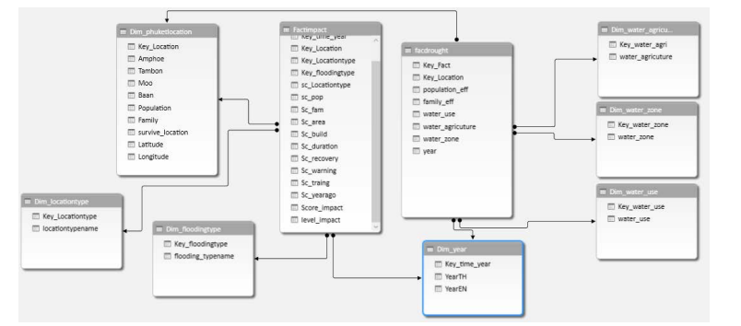
Source: Adapted from Panrungsri and Sangiamkul., (2017) [18]
Panrungsri and Sangiamkul were able to conclude that Business Intelligence can provide agility capacity for decision making in the dynamic environment (Panrungsri and Sangiamkul, 2017). Overall, disaster- prone countries can handle disasters better by integrating BI models in disaster management to gain accurate insight for better predictive analysis. As a result, countries can improve their recovery efforts and disaster preparedness based on the prioritisation of affected areas, based on the the aftermath of the disaster rather than predictive models.

BI analytics and data visualisation
Figure 6.
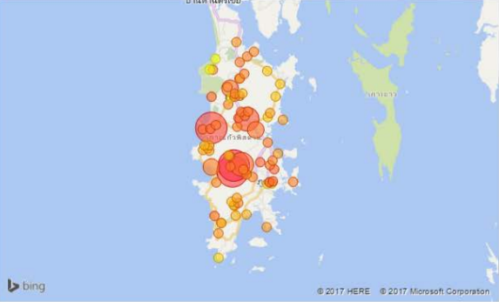
Source: Adapted from Panrungsri and Sangiamkul., (2017) [18]
Data gathered from GIS data, data sheets and tables underwent the ETL process (Extract, Transform, Load), and was organised into the multidimensional star schema model, as shown in Figure 5. This was then analysed using the OLAP (Online Analytical Processing) engine which was imported into Microsoft Power BI desktop. As a result, the visualisation in Figure 6 represents an overview of severity in risk areas of floods and landslides in Phuket Province (Panrungsri and Sangiamkul, 2017).
The researchers were able to gain insight into the landslides through one of the fact tables: FACT_FLOOD_LANDSLIDE. As a result, they were able to analyse the score of severity and the severity level in each tuple of the multidimensional model (Panrungsri and Sangiamkul, 2017). Overall, the power of BI visualisation and multidimensional models can enable countries to effectively identify high-risk areas, which emergency services can prioritise and provide efficient resource allocation. Therefore, transforming multidimensional models into useful visualisations can enable countries to recognise high-risk areas and monitor trends for effective resource allocation and proactive disaster response. The map above uses circles and colours to depict the danger of that area. Each circle corresponds to a village in the area and the size of the circle represents the severity score. The severity score is based on multiple factors: Geographical features, population affected, households and buildings damaged, disaster duration, rescue tools, warning system, training staff and number of occurrences in the past (Panrungsri and Sangiamkul, 2017). Moreover, the colour scheme of the circles ranges from yellow (low severity) to red (high severity). Clearly, the cluster of red and dark orange circles located in the central and southern parts of Phuket appear to experience the higher severity of floods and landslides. Thus, it is likely that these areas are prioritised first for efficient resource allocation, recovery efforts and strategic emergency planning. Ultimately, implementing BI analytics and visualisation, high-risk areas can receive urgent support reinforcing resource allocation strategies. Through visually presenting spatial data, numerous disaster agencies can have better streamlined communication allowing them to coordinate well.
Figure 7.
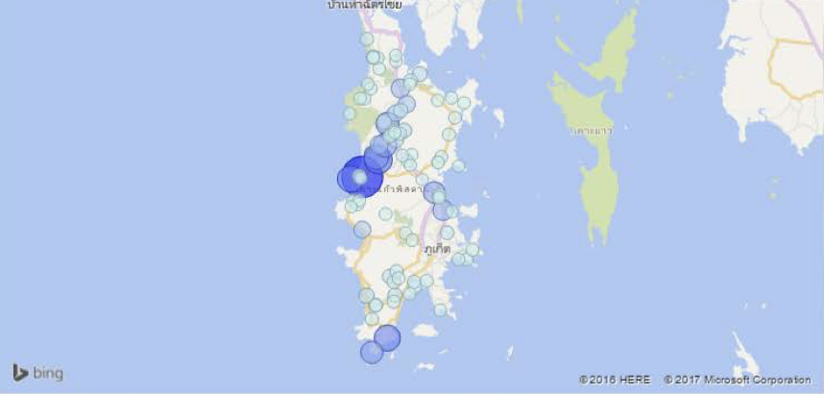
Source: Adapted from Panrungsri and Sangiamkul., (2017) [18]
As seen in Figure 7, the visualisation represents the proportion of the population affected by the drought in Phuket. Each blue circle represents an area, with the size corresponding to the impact of the drought and the colour of circle indicating the severity of the impact – the darker circles represent areas that have a high number of casualties from the disaster. This graph shows the effectiveness of pairing Business Intelligence analytics with GIS data. Overall, creating these visualisations can potentially improve the flood predictions in certain areas because disaster agencies will be able to prioritise these high-risk areas that suffer from droughts, enabling them to improve disaster response and resource allocation to those high-risk areas. Ultimately, BI analytics and visualisation is a crucial tool for disaster planning and resource allocation in assisting disaster agencies to recognise high-priority areas to provide important resources such as food and water. By pinpointing these areas, disaster agencies can deploy rescue teams for efficient resource allocation and proactive disaster response. As opposed to prioritising areas based on post-disaster impacts, this particular model focuses on the risks and, therefore, concerns the predictive analysis of models.

GIS for Flood Disaster Management (Case Study for Allahabad Sadar, India)
This case study entails how Geographical Information Systems have been implemented to identify flood prone areas. To achieve their aim of flood disaster management, a GIS software ‘ArcView’ was used to obtain spatial information to manage floods in high-risk areas. It is a reliable system for integrating data, conducting expert analysis and visualising the results using quality maps and data displays . ‘ArcView’ is the world's most popular desktop mapping and geographic information system software. It is a powerful tool for the visualisation, query, management and analysis of spatial information. The ‘ArcView’ offers capabilities such as mapping, spatial analytics, 3D Geographical Information Systems and many more. Among many of these capabilities, spatial analytics serves to be one of the most effective ways to find solutions for challenges. This is because spatial analytics uses location as a connective thread to assist understanding on how the environment affects the many challenges that people are finding solutions for . In this case, resource allocation is one of the challenges faced in disaster management. By thoroughly examining data in relation to its geographic location, unexplored spatial patterns, trends and connections can be noted . For that reason, ArcView offers many benefits in improving resource allocation in disaster prone areas as it can provide valuable insight on areas that are likely to be widely affected by those disasters. Considering this, the GIS system ‘ArcView’ was used to create various thematic maps: road networks, drinking water sources, land use, population density, ward boundaries and location of slums (Abbas et al., 2009). These thematic maps provide critical decision for disaster management, enabling rescue teams to plan evacuation routes, follow relief maps and monitor the distribution of aid. Ultimately, the case study demonstrates how GIS based systems can produce a model to improve disaster management and support the decision-making process to mitigate disasters in more susceptible areas.
Figure 8.
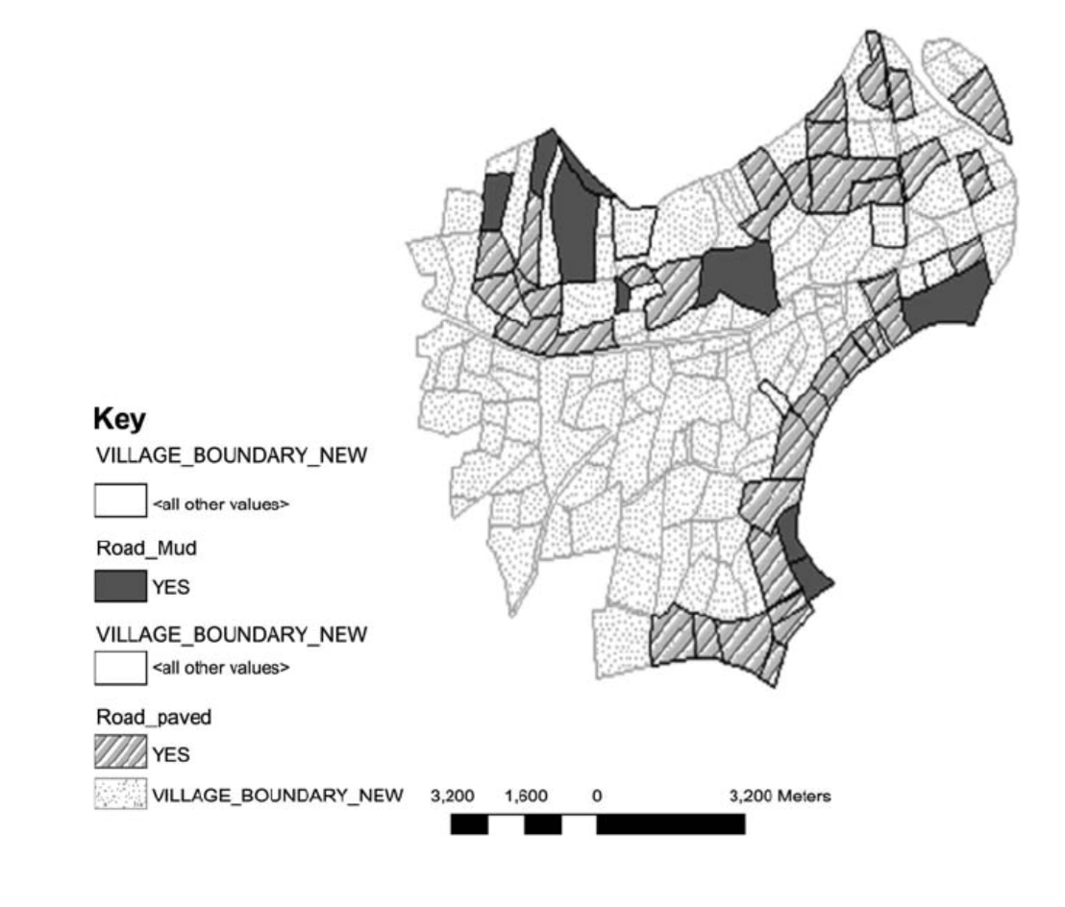
Source: Adapted from Abbas et al., (2009) [1]
As seen in Figure 8, the GIS map represents the road connectivity in flood prone areas within Allahabad Sadar. Based on the key, they are two types of roads: mud roads which are the dark grey areas in the map, and paves roads which are the light grey patterned areas on the map. This map can be important for gaining insight on transportation of teams and resources in certain areas. It is evident that mud roads are more vulnerable to floods because of the soft composition, making it easier to erode. Therefore, villages that have mud roads are at greater risk of receiving less support for medical teams, emergency services and escape routes. This is because ground vehicles carrying supplies will have more difficulty travelling on these roads. As a result, by identifying the villages that are only accessible by mud roads, disaster agencies can prioritise these areas for optimal emergency relief for enhanced disaster response, perhaps by specifically arranging for resources to be transported by aircraft. On the other hand, villages that are accessible thorough paved roads are durable and reliable which can facilitate quicker aid and faster rescues using ground vehicles. This can be helpful for nearby villages with mud roads as these paved roads can be prioritised for relief jobs and transporting resources such as food, water and medical supplies. Overall, the GIS based map visualisations not only provide insight into different types of roads in the flood risk areas, but it also allows local government agencies to start road upgrades in high-risk areas supporting infrastructure development. By upgrading the infrastructure, flood prone areas are more likely to be resilient against floods.
Figure 9.
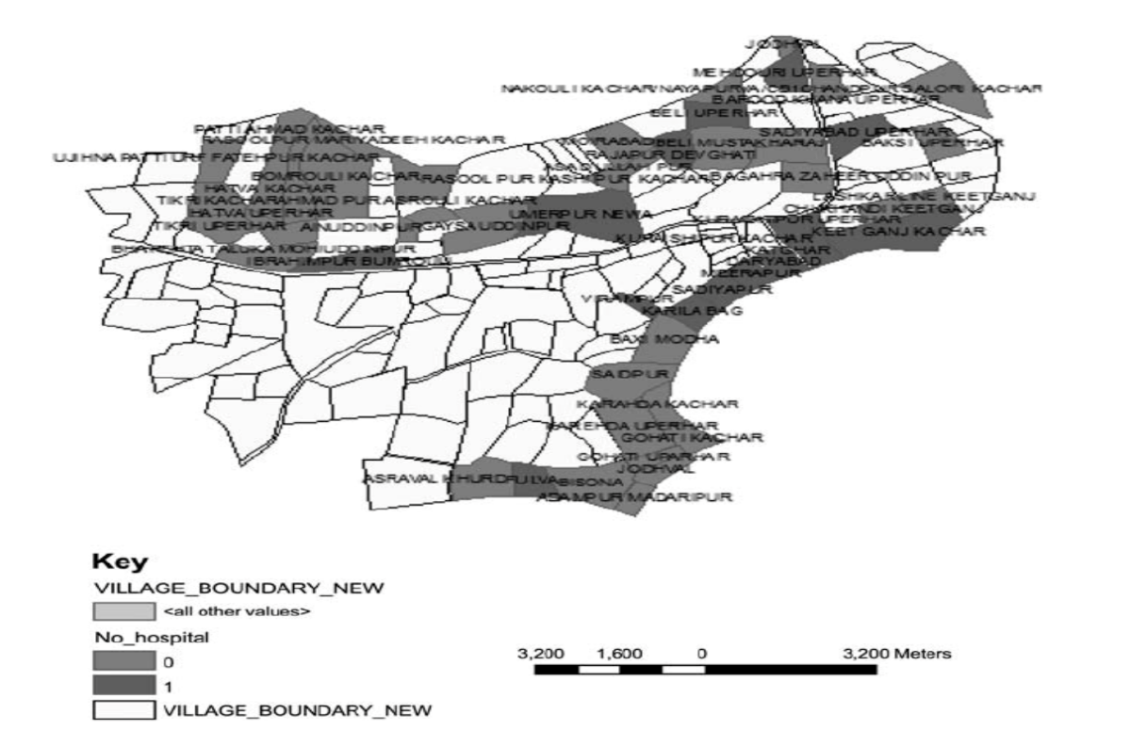Source: Adapted from Abbas et al., (2009) [1]
Secondly, the GIS based map represents the amount of hospital facilities in certain areas (See Figure 9). It has a key with light grey areas indicating zero hospitals and dark grey areas indicating at least one hospital in the area. It is evident that the study area does not have many healthcare facilities, with certain areas facilitating only one hospital. This means that it is important for victims to receive medical care as soon as possible. This GIS map can allow disaster agencies to identify areas that have less hospital facilities, enabling authorities to give priority to those villages. With regards to resource allocation, this map ensures that healthcare resources are dispersed based on visibility and accessibility. Hence, villages that do not have access to healthcare facilities can be provided with medical supplies after an occurrence of a flood. In summary, the GIS based map gives key insights in dispersing healthcare resources which can be a necessary tool for effective disaster response. Therefore, by highlighting areas that lack healthcare facilities, disaster agencies can respond more effectively and make sophisticated choices to protect vulnerable communities and disaster-prone areas.
Figure 10.
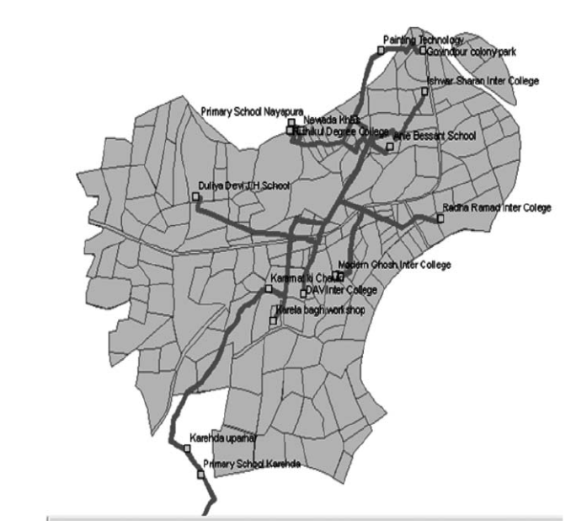
Source: Adapted from Abbas et al., (2009) [1]
To provide sufficient resource allocation to affected areas, relief camps or disaster shelters can be possible solution. As seen on Figure 10, a map was generated consisting of different routes to various relief camps. GIS mapping makes it possible to understand the proximity of villages from the relief camps. Relief camps have a significant impact during and after disasters because affected victims can access these camps for shelter and basic resources such as food, water and even medical care. By identifying the routes to different camps, resource allocation can be planned before and after disasters ideally prioritising areas that struggle with transporting goods and receiving aid. This supports proactive disaster response and preparedness as by mapping out all the relief camp locations and the routes, disaster agencies can identify any inaccessible routes. With this insight, they can create new supply routes that are accessible before a disastrous event and send resources to the relief camps ahead of time. As a result, efficient resource allocation can be achieved as the relief camps can not only be accessed in accessible areas but reach out to more secluded areas. Overall, this GIS visualisation representing the different route to relief camps allows for efficient distribution of supplies in disaster prone areas, based on the pre-existing resource accessibility and availability.
On the whole, the case study on flood management in Allahabad Sadar, sub-district in India, demonstrates how effective Geographical Information Systems (GIS) can be utilised for better resource allocation in disaster prone areas by making decisions based on risk susceptibility. By generating GIS-based maps, one can visualise the situation at hand to make well informed decisions. For instance, the road infrastructure map in Figure 8 is crucial for recognising the challenges of transporting resources or sending rescue teams to nearby villages or settlements affected by the flood. By pinpointing these areas, district authorities can prioritise areas that have poor infrastructure like mud roads. These areas are more likely to have delayed emergency assistance as damp mud roads introduce difficulty in transporting resources to those areas. On the other hand, paved roads have a better chance at transporting resources and distributing them. This is due to their ability to withstand water absorption causing surface runoff which enables emergency services to facilitate the rapid distribution of medical assistance and resources. Thus, modes of transporting supplies can be specified by the road type, with aircraft being more ideal for mud roads and ground vehicles being more ideal for paved roads. Similarly, the healthcare facility GIS-based map in Figure 9 highlights a crucial insight into the distribution of available medical services in the study area. As seen in Figure 9, it is clear that numerous villages lack access to hospitals, rendering them vulnerable in the event of a flood. Through GIS-based analysis of these challenges, local government authorities can prioritise these areas to allocate resources and medical supplies. Therefore, focusing on resource distribution ensures that healthcare resources are distributed evenly between areas. Finally, in Figure 10, the relief camp route network further supports the case study for GIS systems in disasters. The relief camp route network indicates how spatial analysis can be utilised to determine the distance between villages and the relief camps. These relief camps are essential for affected communities as they not only provide shelter but also, food, water and medical assistance. Through the use of the ArcView GIS system, emergency services can map all access routes to the relief camps, creating an efficient and reliable emergency service response system that can assist distant villages.

Results
The BI model in Phuket, Thailand had a couple of key outcomes. Firstly, the BI model clearly demonstrates the importance of disaster data, whether it is unstructured or structured, as it subjected to many processes in the model, which ensures that the data is transformed and visualised for better decision making. Next, the multidimensional star schema demonstrates how large datasets can be used for querying which involves requesting access to data so that it can be retrieved for analysis and visualisations. Additionally, as shown in Figure 6 and Figure 7, visualisation tools like Microsoft Power BI provide useful insights in disaster prone areas revealing the risk of severity in areas, population and overall damage. This allows authorities to prioritise high risk areas, improving response and distribution of resources. In the Allahabad Sadar case study, the GIS system ‘ArcView’ was used to identify flood risk areas through spatial analysis of healthcare access, relief camp routes and roads. Also, the use of GIS-based maps can help emergency services to carefully evaluate the infrastructure vulnerability to create schemes for strategic disaster planning. Finally, authorities can perceive the visualisations consisting of data on roads, healthcare facilities and relief camps for immediate disaster response and resource distribution.

Discussion
The aim of this research was to explore how Business Intelligence (BI) and Geographical Information Systems (GIS) can address two challenges in disaster management: resource allocation and delayed response. Through researching existing literature and analysing in-depth case studies on the BI framework in Phuket, Thailand and the GIS-based system in Allahabad Sadar, India, the study illustrates how Business Intelligence and Geographical Information Systems can be a solution to solving these issues.
One of the aims of this research was to explore how BI and GIS systems can be used for proactive disaster response. The BI framework case study in Phuket, exhibits a solution on handling a large volume of data from many sources like datasets. The conceptual BI framework has several stages, each of which are important in transforming data into valuable insights. These stages include the Extract, Transform and Load (ETL) processes, multidimensional star schema models, OLAP (Online Analytical Processing), data visualisation and dashboards. As a result, these insights were then imported into the Microsoft Power BI desktop to create visualisations to identify trends and patterns for predictive analysis in disaster prone areas enabling local government authorities to make data-driven decisions before disasters arise which can improve disaster response.
Additionally, Geographical Information Systems also play an important role for proactive disaster response. As seen for both case studies, GIS data was used for spatial analysis and visualisation for disaster-prone areas. For instance, the GIS road type map in Figure 8 allows emergency response services to pinpoint areas that are accessible and inaccessible, enabling them to prioritise inaccessible areas, significantly improving disaster response. Furthermore, the GIS maps also show insight into healthcare facilities and relief camps around the area, enabling local government authorities to efficiently deploy rescue teams more strategically during or after a disaster. Therefore, both GIS and BI not only provide preliminary warning systems but also the data infrastructure needed to ensure that disaster response planners are informed immediately.
The second aim of this research was to explore how BI and GIS can improve the distribution of resources after disasters. The conceptual BI model for the Phuket generated the visualisations in Figure 6 and Figure 7, specifically through the multidimensional star schema depicting the relevant fact tables and dimensions. From this, the severity of landslide risks and droughts can be highlighted, allowing for more efficient identification of high-risk regions which can be prioritised so that these areas are supplied with resources before and immediately a disaster. Similarly, the GIS ‘ArcView’ utilised for flood disaster management in Allahabad Sadar provides insight to how resource allocation can be improved. Numerous insights about the infrastructure, relief camps and healthcare access were obtained. These maps show the disparity of the areas, with some having access to healthcare and paved roads whilst others struggle gaining access to these.

Conclusion
The Phuket case study shows a clear demonstration of how the Business Intelligence framework can improve disaster management which can improve disaster response and even resource allocation. It exemplifies the implementation of BI in disaster-prone regions, showing the importance of the ETL processes, visualisations and multidimensional modelling in supporting decision-making processes. By integrating different techniques and technologies like the star schema model, the researchers were able to make use of the data on floods, droughts and landslides into a data warehouse. Notably, using Microsoft Power BI with one of the fact tables in the model allowed researchers to produce detailed visualisations showing the severity level and the score of severity of the disasters. These BI visualisations can provide analysts and disaster agencies with information concerning high-risk areas, which can then be prioritised. The implementation of this BI model demonstrates the use of BI tools to tackle delayed response and inefficient resource allocation. Knowledge gained from this case study broadens my understanding of how these technologies can enhance disaster management in disaster prone regions.
Furthermore, from the ‘ArcView’ GIS case study in Allahabad Sadar, a clear trend be identified in these maps: Geographical Information Systems enables efficient resource allocation to be achieved by transforming useful data for meaningful analysis. It enables authorities to visualise these issues before they arise, ensuring proactive disaster response. Ultimately, Geographical Information Systems are not only a tool for mapping and visualisation, but it can also be used for data-driven decision making. It encourages authorities to respond quicker, provide efficient resource distribution and deploy strategic disaster planning for proactive disaster response. Thus, integrating GIS-based mapping into disaster management provides a safer for better responsiveness in disaster prone areas.
Overall, BI and GIS models can be used to achieve different methods of prioritisation. As highlighted in the case studies examined, examples of prioritisation systems include: severity of impact (post-disaster based), severity of risk (pre-disaster based), availability and accessibility of resources (based on the current state of the region). These ranking systems drive the allocation of resources in terms of how supplies are transported, the quantity of supplies and the type. In turn, the response time can be adjusted for each area.

Future Work
While Business Intelligence and Geographical Information Systems demonstrate their effectiveness, there are several improvements that can be made for future development. In terms of future work, there are a couple of things that could have been done if there was more time and resources. Firstly, if there was more time, the methodology would include additional case studies based on different disaster scenarios. This would have allowed for better analysis and comparison of how BI or GIS has been effective in certain disasters. Broadening the research by including case studies on how disaster response in earthquakes, tsunamis or wildfires were improved with different technologies would have strengthened this study. This is because Business Intelligence in disaster management is still relatively obscure in this field of research. Therefore, if more time was available, further research could have been conducted on existing technologies that are adopted in more fields such as real time sensor networks. From this, researching real-time sensor networks would have been a more suitable direction due to its ability to monitor data in real-time, making it reliable in monitoring data in disaster prone environments. Furthermore, exploration on how different technologies could have been integrated together to create hybrid models consisting of different systems could have been carried out. For example, importing IoT real-time sensor data into BI visualisations and dashboards could have shown the importance of real-time data in a disaster response and resource allocation.

Bibliography
- Abbas, S.H., Srivastava, R.K., Tiwari, R.P. and Bala Ramudu, P. (2009). GIS‐based disaster management. Management of Environmental Quality: An International Journal, 20(1), pp.33–51. doi: https://doi.org/10.1108/14777830910922433‌
- Alkharouf, N.W., Jamison, D.C. and Matthews, B.F. (2005). Online Analytical Processing (OLAP): A Fast and Effective Data Mining Tool for Gene Expression Databases. Journal of Biomedicine and Biotechnology, [online] 2005(2), pp.181–188. doi: https://doi.org/10.1155/jbb.2005.181
- Alijoyo, F.A., Pradhan, R., Vats, S., Rani, V., Kholmukhamedov, T. and Karthik, M. (2024). AI-Powered Business Intelligence for Smarter Decision-Making and Growth. [online] pp.1–5. doi: https://doi.org/10.1109/icaiqsa64000.2024.10882218
- BIRTE and Bussler, C. (2007). Business intelligence for the real-time enterprises: first international workshop, BIRTE 2006, Seoul, Korea, September 11, 2006, revised selected papers. In: C. Bussler (ed.). Berlin: Springer-Verlag. doi: https://doi.org/10.1007/978-3-540-73950-0
- Bouttell, A.B., Lee, S., Leung, C.K., Levesque, M.J., Son, S., Zhang, W. and Cuzzocrea, A. (2022). Predictive Analytics for Supporting Environmental Sustainability and Disaster Management. [online] IEEE Xplore. doi: https://doi.org/10.1109/COMPSAC54236.2022.00198
- Candidate, P. (n.d.). The Role of Data Warehouse during the Natural Disaster ZIJADIN KRASNIQI. [online] Available at: https://euacademic.org/UploadArticle/1997.pdf
- Chua, A.Y.K., Kaynak, S. and Foo, S.S.B. (2007). An analysis of the delayed response to Hurricane Katrina through the lens of knowledge management. Journal of the American Society for Information Science and Technology, 58(3), pp.391–403. doi: https://doi.org/10.1002/asi.20521
- Giardino, M., Perotti, L., Lanfranco, M. and Perrone, G. (2012). GIS and geomatics for disaster management and emergency relief: a proactive response to natural hazards. Applied Geomatics, 4(1), pp.33–46. doi: https://doi.org/10.1007/s12518-011-0071-z
- Hu, Z., Li, X., Sun, Y., Gong, Z., Wang, Y. and Zhu, L. (2007). Flood disaster response and decision-making support system based on remote sensing and GIS. [online] IEEE Xplore. doi: https://doi.org/10.1109/IGARSS.2007.4423334
- Ieee.org. (2024). Emergency situations monitoring using OLAP technology. [online] Available at: https://ieeexplore.ieee.org/abstract/document/6240906
- Jefferson, T.L. and Johannes, T.W. (2016). Using geographic information systems to support decision making in disaster response. Intelligent Decision Technologies, [online] 10(2), pp.193–207. doi: https://doi.org/10.3233/idt-160255
- KARACAN, H. and Şirin, E. (2017). A Review on Business Intelligence and Big Data. International Journal of Intelligent Systems and Applications in Engineering. [online] Available at: https://scholar.googleusercontent.com/scholar?q=cache:9RXSJZLzQe8J:scholar.google.com/+big+data+and+business+intelligence&hl=en&as_sdt=0
- Khan, S.M., Shafi, I., Butt, W.H., Diez, I. de la T., Flores, M.A.L., Galán, J.C. and Ashraf, I. (2023). A Systematic Review of Disaster Management Systems: Approaches, Challenges, and Future Directions. Land, [online] 12(8), p.1514. doi: https://doi.org/10.3390/land12081514
- Kirilenko, A. (2022). Geographic Information System (GIS). In: Tourism on the Verge, pp.513–526. doi: https://doi.org/10.1007/978-3-030-88389-8_24
- Kiani Mavi, R. and Standing, C. (2018). Cause and effect analysis of business intelligence (BI) benefits with fuzzy DEMATEL. Knowledge Management Research & Practice, 16(2), pp.245–257. doi: https://doi.org/10.1080/14778238.2018.1451234
- Mondal, T., Boral, N., Bhattacharya, I., Das, J. and Pramanik, P. (2019). Distribution of deficient resources in disaster response situation using particle swarm optimization. International Journal of Disaster Risk Reduction, 41, p.101308. doi: https://doi.org/10.1016/j.ijdrr.2019.101308
- Olszak, C. and Ziemba, E. (2006). Business Intelligence Systems in the Holistic Infrastructure Development Supporting Decision-Making in Organisations. Interdisciplinary Journal of Information, Knowledge, and Management, [online] 1. Available at: https://ijikm.org/Volume1/IJIKMv1p047-058Olszak19.pdf
- Panrungsri, T. and Sangiamkul, E. (2017). Business Intelligence Model for Disaster Management: A Case Study in Phuket, Thailand. [online] Available at: https://idl.iscram.org/files/tanapornpanrungsri/2017/2060_TanapornPanrungsri+EstherSangiamkul2017.pdf
- Rasekh, A. and Vafaeinezhad, A.R. (2012). Developing a GIS Based Decision Support System for Resource Allocation in Earthquake Search and Rescue Operation. Lecture Notes in Computer Science, pp.275–285. doi: https://doi.org/10.1007/978-3-642-31075-1_21
- Richardson, T. and Renner, R. (2007). Geographic Information Systems Supporting Disaster Response and Recovery. Cityscape, [online] 9(1), pp.189–215. doi: https://doi.org/10.2307/20868612
- Tin, D., Cheng, L., Le, D., Hata, R. and Ciottone, G. (2024). Natural disasters: a comprehensive study using EMDAT database 1995–2022. Public Health, 226, pp.255–260. doi: https://doi.org/10.1016/j.puhe.2023.11.017

DataCalculus (2025). BI for Disaster Management: Enhancing Resilience Through Data Analytics. [online] DataCalculus. Available at: https://datacalculus.com/en/knowledge-hub/business-intelligence/case-studies-and-industry-applications/bi-for-disaster-management
BI for Disaster Management: Enhancing Resilience Through Data Analytics
Organizational Resilience (n.d.). 5 Phases of Emergency Management | Organizational Resilience. [online] University of Nevada, Reno. Available at: https://www.unr.edu/organizational-resilience/phases
5 Phases of Emergency Management | Organizational Resilience
BasuMallick, C. (2022). What Is MapReduce? Meaning, Working, Features, and Uses. [online] Spiceworks. Available at: https://www.spiceworks.com/tech/big-data/articles/what-is-map-reduce/ ‌
sreekzz (2024). What is Apache Hive and HiveQL - Azure HDInsight. [online] learn.microsoft.com. Available at: https://learn.microsoft.com/en-us/azure/hdinsight/hadoop/hdinsight-use-hive ‌
ArcView ®. (n.d.). Available at: http://downloads.esri.com/support/whitepapers/ao_/arcview81bro.pdf
ArcView ®. (n.d.)
Spatial analytics: Seize market opportunities & plan for the future (no date) Spatial Analytics | Seize Market Opportunities & Plan for the Future. Available at: https://www.esri.com/en-us/capabilities/spatial-analytics-data-science/overview (Accessed: 06 April 2025).
Spatial analytics: Seize market opportunities & plan for the future (no date) Spatial Analytics | Seize Market Opportunities & Plan for the Future.

